**Q3. What are loops, and what do we need them? Explain different types of loops with their syntax and examples.**

Loops are programming constructs that allow the repeated execution of a block of code until a certain condition is met. They are essential for automating repetitive tasks, iterating over data structures, and controlling the flow of a program.

In JavaScript, there are three main types of loops:

**1. for loop:**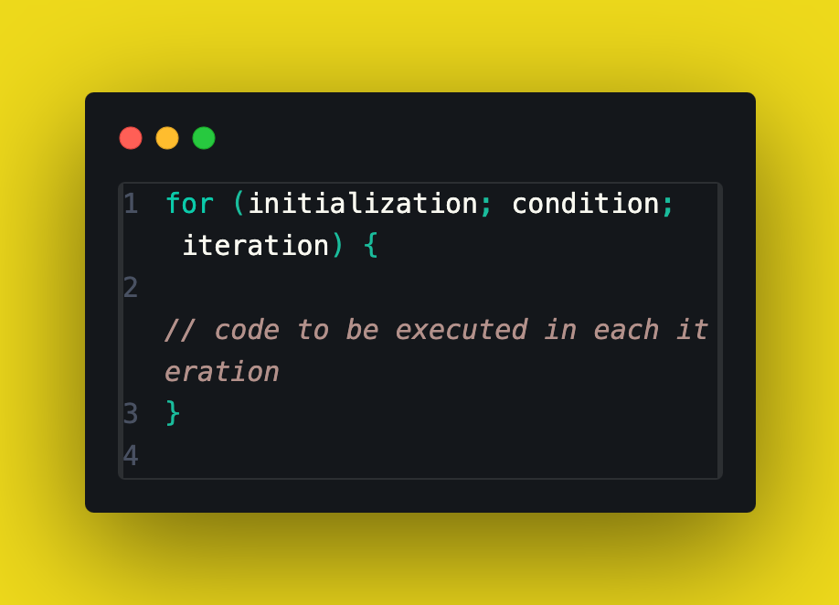

**Syntax**:

code needs to be executed repeatedly until a certain condition is met. The choice of loop depends on the specific requirements of the task at hand.